SPORTS INTERNSHIP OPPORTUNITY
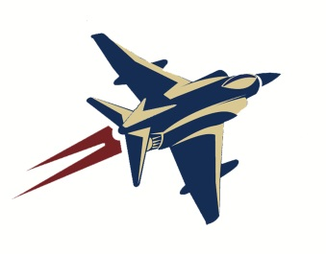
Janesville Jets, North American Hockey League
Part Time & Full Time
Offseason (May-Sept)
Half-Season (Sept-Dec; Jan-May)
Full Season (Sept-May)

The Janesville Jets Hockey Club, recipients of the NAHL’s 2015 Organization of the Year Award, are looking for motivated, passionate interns to assist with operations during the 2017-2018 season. Jets internships are full-time or part-time and allow students the opportunity to gain valuable work experience within a sports organization through hands-on experience. A successful applicant will demonstrate strong organizational skills along with initiative, resourcefulness, and an ability to collaborate with team members for the achievement of team goals. In past years, Jets interns have been successful in securing full time positions across a wide field of industries post-internship. Career mentoring is a central aspect to the Jets internship program.
Account Executive Internship
Client Sales, Office Management, Community Relations, Game Night Operations, Fan Experience
- Responsibilities
  - Maintain ongoing target list and complete sales calls to secure group outings
  - Sell group tickets and ticket packages
  - Answer inbound calls
  - Assist with ticketing during home games
  - Provide customer service
  - Serve as Jets liaison at community events
  - Maintain ticket sales files and complete important client data entry
- Qualifications
  - Exceptional customer service skills
  - Self-starter and highly motivated
  - General knowledge of Microsoft Office and Google Documents
  - Effective and engaging communicator
- Compensation
  - 7% commission on all ticket sales
  - School credit available in accordance with school and program qualifications

- To apply, please send cover letter and resume to mason@janesvillejets.com

Mason Lyttle
Director of Business Operations
608-352-7488
mason@janesvillejets.com

